Our uniform policy is designed to accommodate the varied sensory preferences and needs of our students.
We ask that students wear:
- Black trousers, black joggers (not ripped/faded), black skort/skirt with undershorts or black school shorts. Please ensure that leggings, if worn, are suitably opaque.
- A school-branded sweatshirt, a school-branded hoody or a school-branded fleece. Two t-shirts will be provided by the school, along with 2 of either sweat shirt, fleece or hoody.
- Shoes should be suitable for school: no heels and they should not have a hardened toe area or be open toe.
- False nails & pendant earrings are not permitted for safety reasons.
We also ask that students bring a suitable and appropriate change of clothes to do PE and Outdoor Education in. However, children can come in kit if they prefer.
Branded Uniform Items
Polo Shirts – Tshirts : (white)
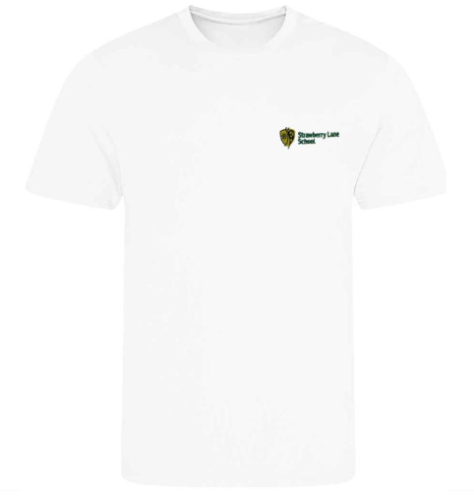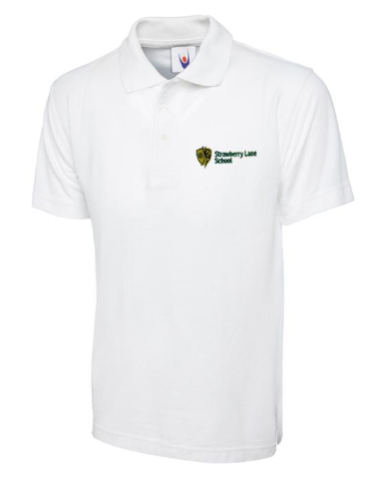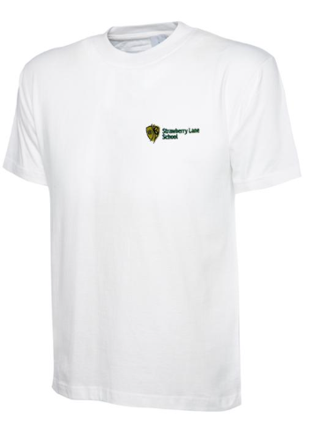

Fleeces/Hoodies/Jumpers: (Bottle Green)
